LinkedU: Use Cases

(Keegan, Jason, Zack)

# Use Case 1: Sign-Up Student

Status: Completed

Implemented In: Main menu under “Guest”

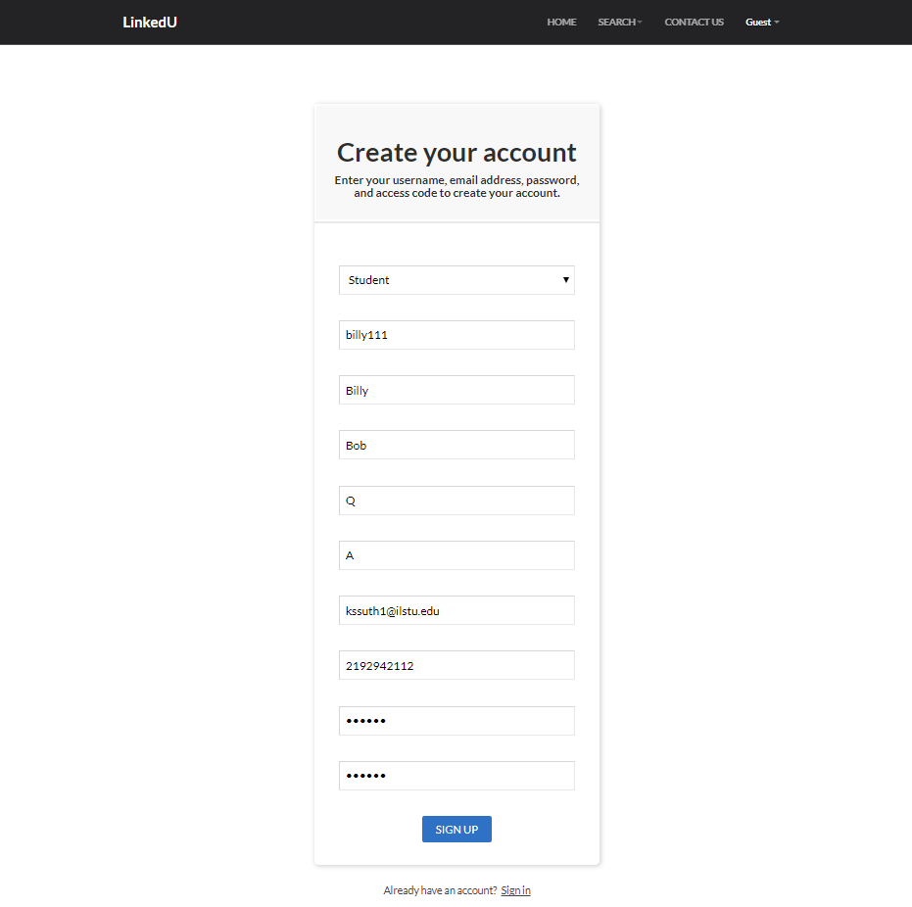

# Use Cases 2/3/4/5:Create Student Profile, Edit Profile, Unsubscribe from newsletter, and Upload Media

Students and Universities can create a profile after signing up. Below are some example fields.

Status: Completed

Implemented In: Main menu under “User”

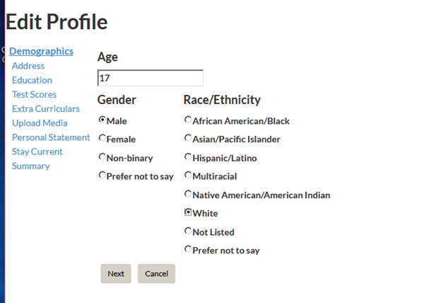

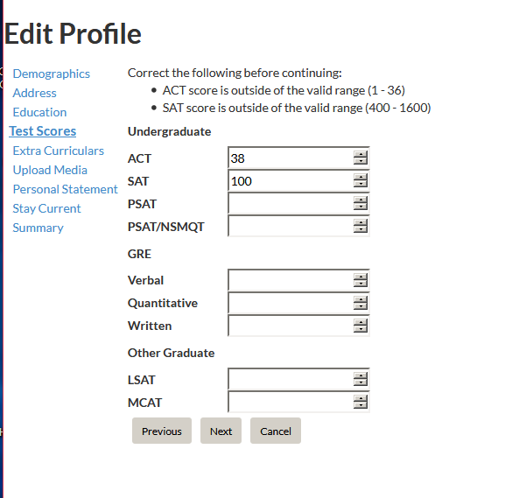

Here you set your home address. This address is later used to search for Universities near you, and to show you how long it would take to get to that University.

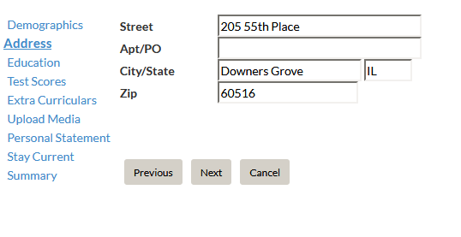

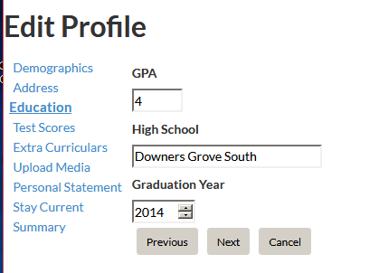

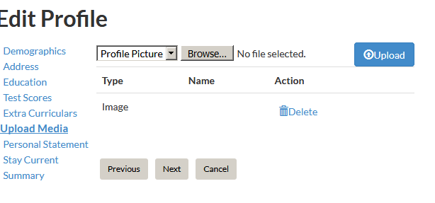

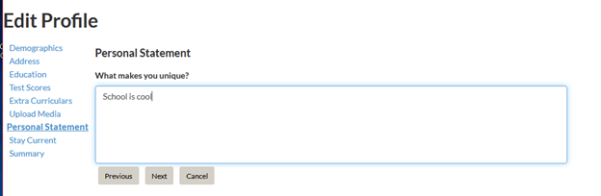

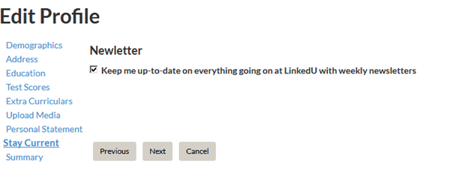

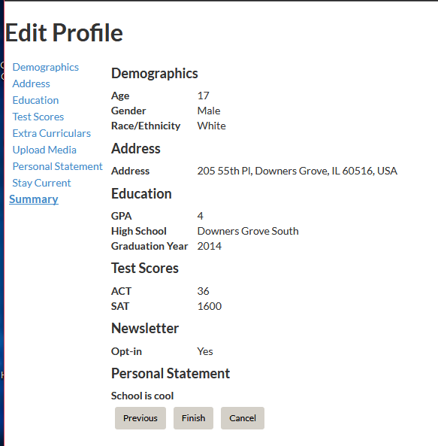

# Use Case 6: Search for Universities

Our University Search functions allows students to search for Universities based on degrees, distance, and distance in relation to their home address (that is entered during profile set up)

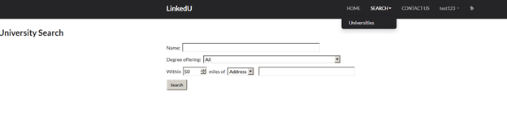

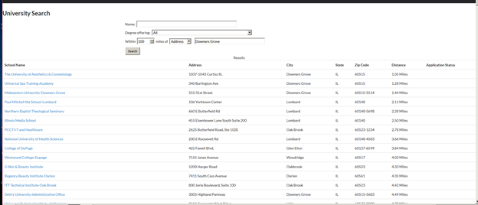

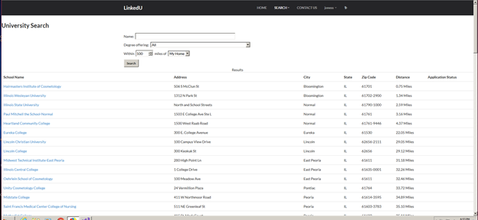

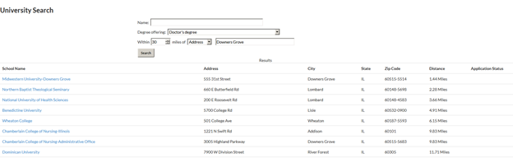

# Use Case 7-8: Reset Password (Email & SMS)

Status: Completed

Implemented In: Bottom of Sign-In page.

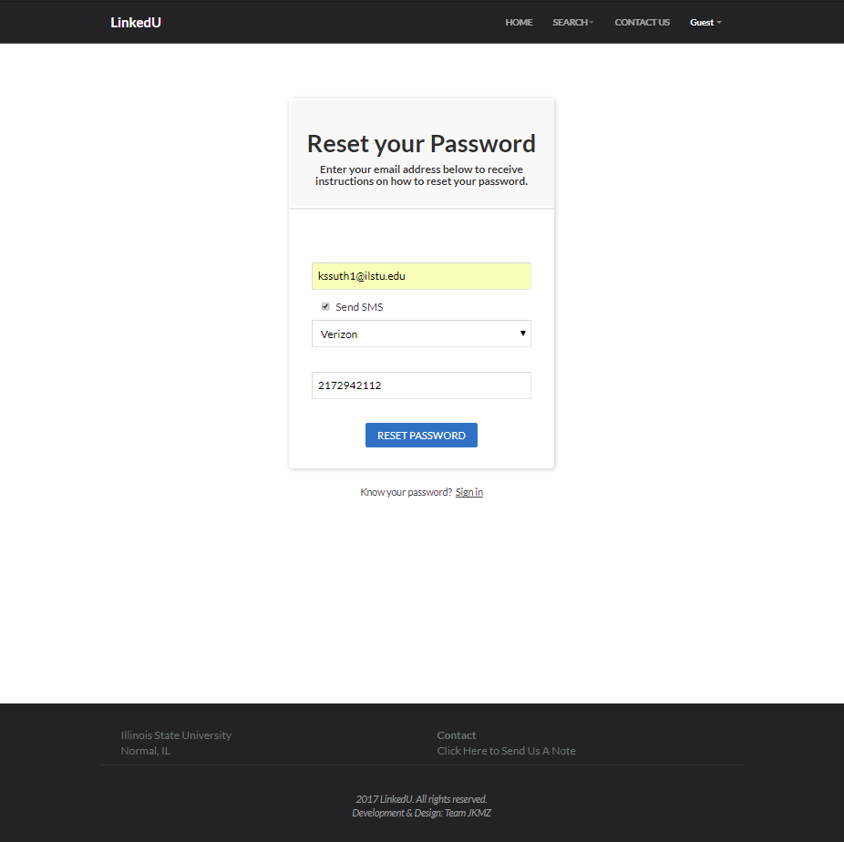

# Use Case 9: Sign-In

Status: Completed

Implemented In: Main menu under “Guest”

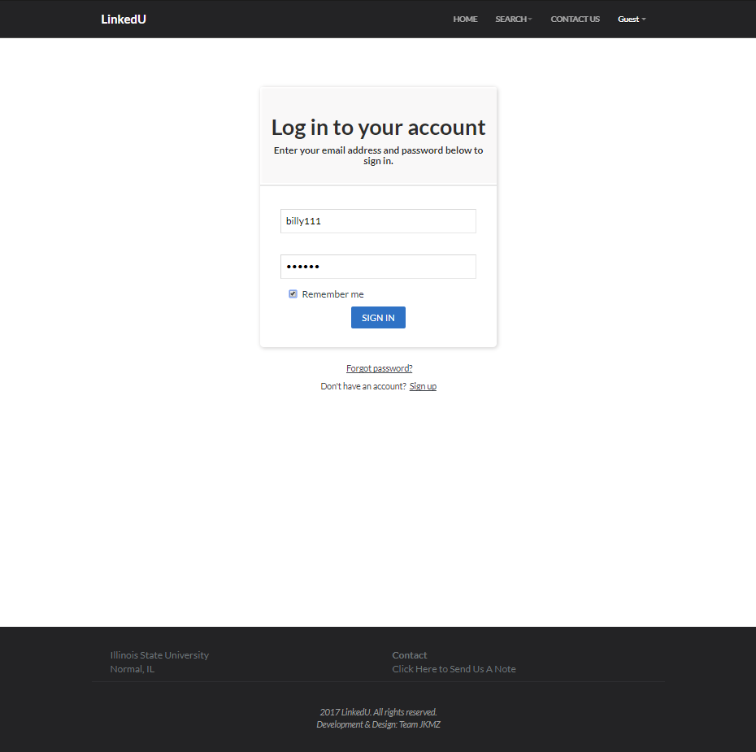

# Use Case 10: Sign-Up University

Status: Completed

Implemented In: Main menu under “Guest”

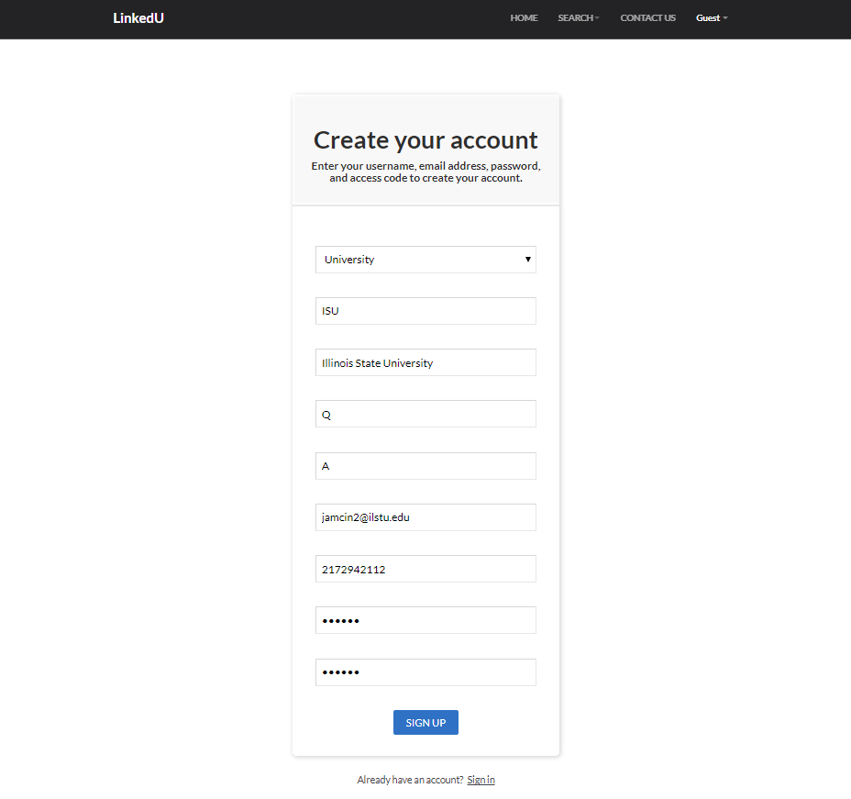

# Use Case 11: Create University Profile

Status: Completed

Implemented In: "University Name" > "Edit Profile";

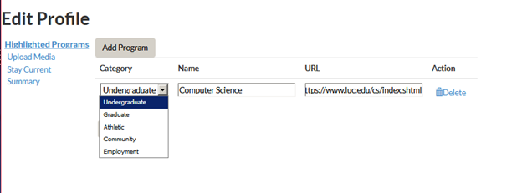

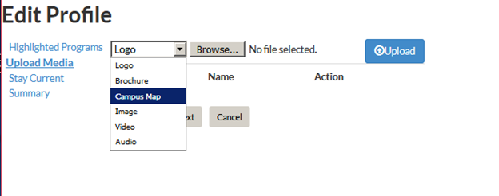

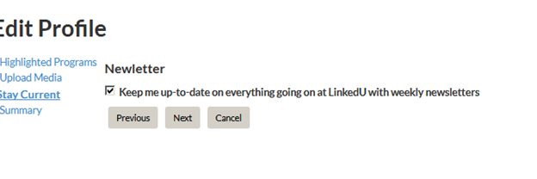

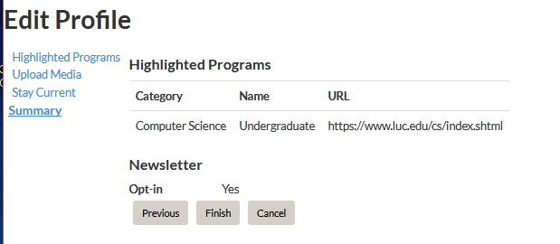

# Use Case 12: View University Notifications

Status: Completed

Implemented In: Main menu bar when signed-in as a university

Unread notifications

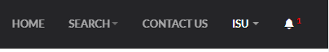

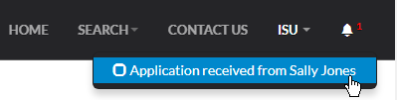

Read notifications

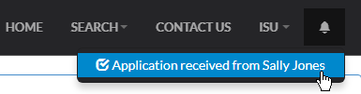

# Use Case 13: Search for Students

Status: Completed

Implemented In: Main menu under “Search for Students” while logged in as a university

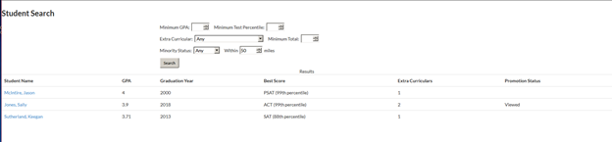

Students with a 4.0 GPA

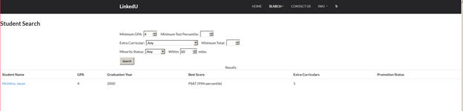

Minority Status

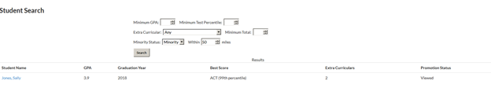

# Use Case 14: Promote to Student

Status: Completed

Implemented In: Student profile page, visible only to users of type University

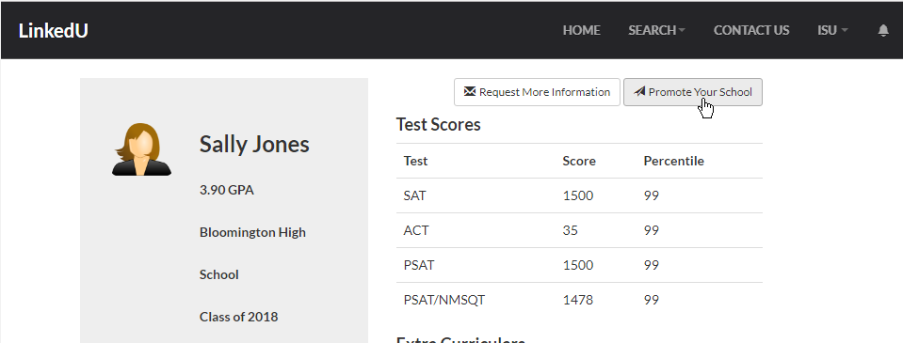

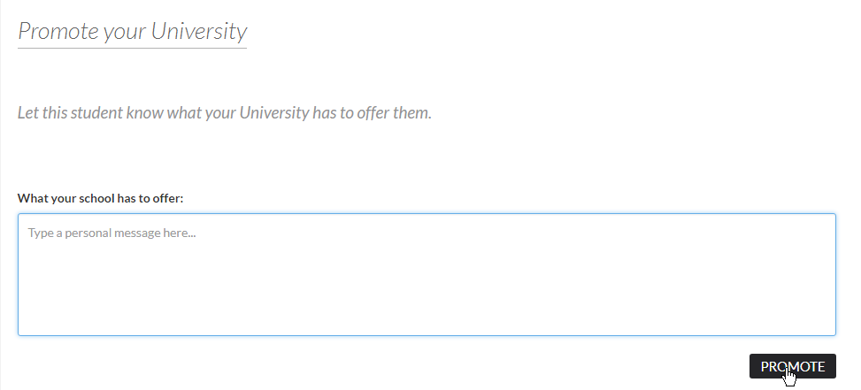

# Use Case 15: Student Notifications

Status: Completed

Implemented In: Main menu bar when logged in as a Student

Unread notifications



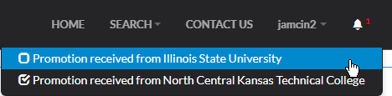

Read notifications

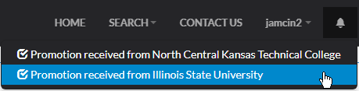

# Use Case 16: Mark a University for Review

Status: Completed

Implemented In: Main menu under “Administrator” while logged in as admin

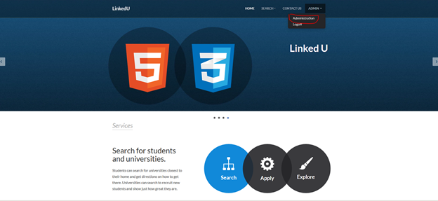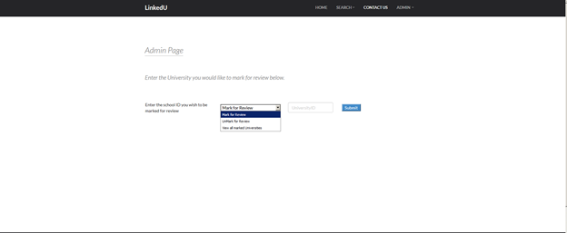

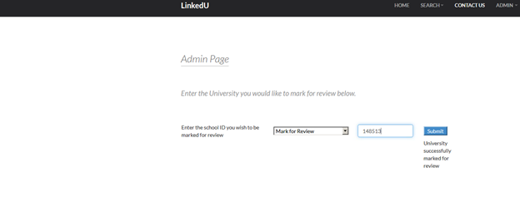

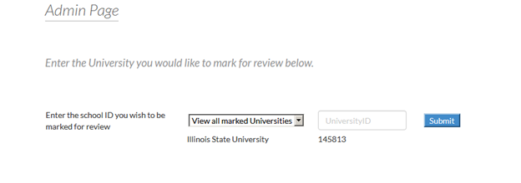

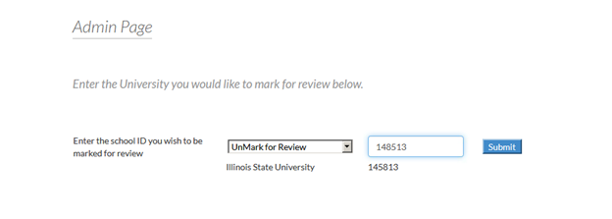

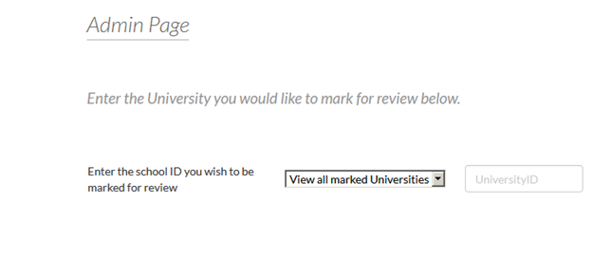

# Use Case 17: Request More Information

The Request for more information feature allows Students to send an email to a University their interested in, requesting that they send back more information about the University.

Status: Completed

Implemented In: Any Universities posting

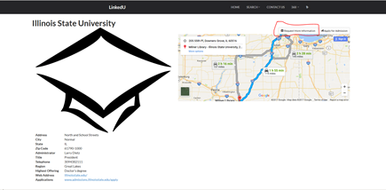

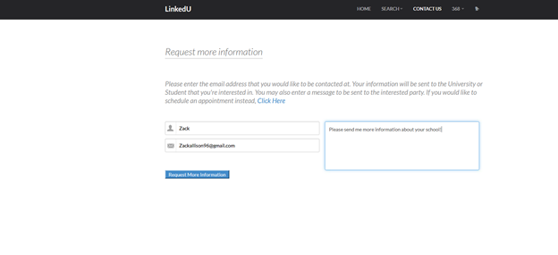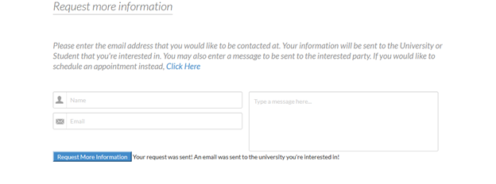

# Use Case 18: Schedule an Appointment

Schedule an appointment allows a student to schedule a time with a University to meet via phone or in person. The University will get an email from our site, stating that a user is interested in meeting with them at a specific time. The student is set as the ReplyTo field, so the University can reply if they are available and interested to confirm the appointment.

Status: Completed

Implemented In: University posting > Request For More Information > Click Here

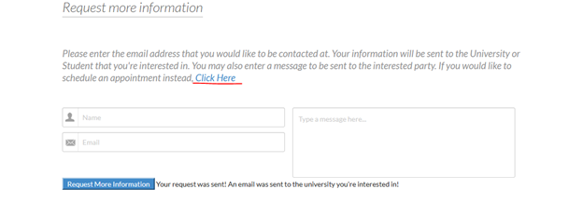

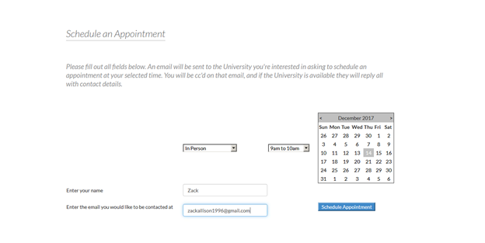

Email confirmation sent to the student scheduling the appointment

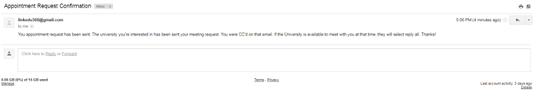

Email sent to the University

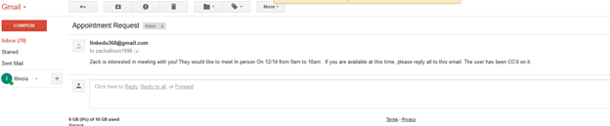

# Use Case 19: View the Featured University

Here is where highlighted/featured Universities are displayed. Currently None are displayed because none are marked for review in the admin section

Status: Completed

Implemented In: Home Page



# Use Case 20: Purchase a Spot as a "Featured University"

Here we allow Universities to purchase a spot on the front page of our website. The link is set to not redirect after purchase, because paypal requires an outward facing website. If we published to an actual website domain, we could redirect back with no issue, but the iis server limits this.

Status: Completed

Implemented In: Home page under "Want your University Featured"



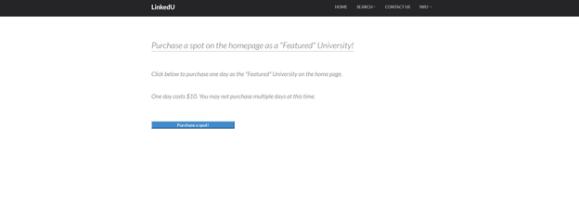

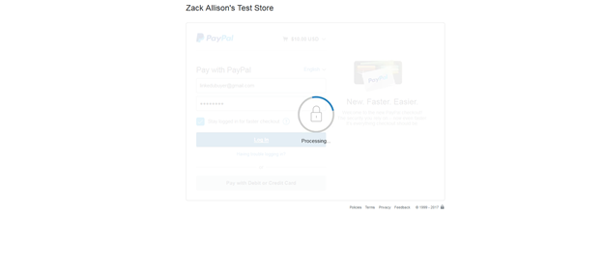

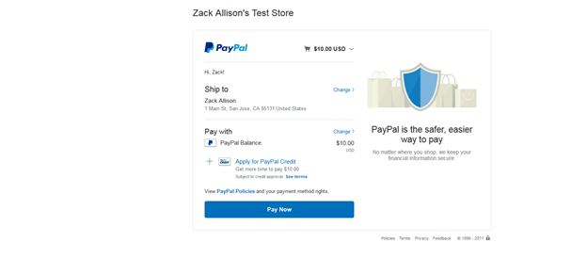

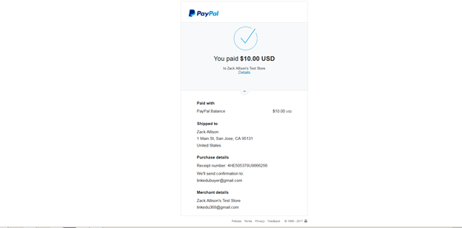

# Use Case 21: Contact us

Status: Completed

Implemented In: Footer of every page and in main menu.

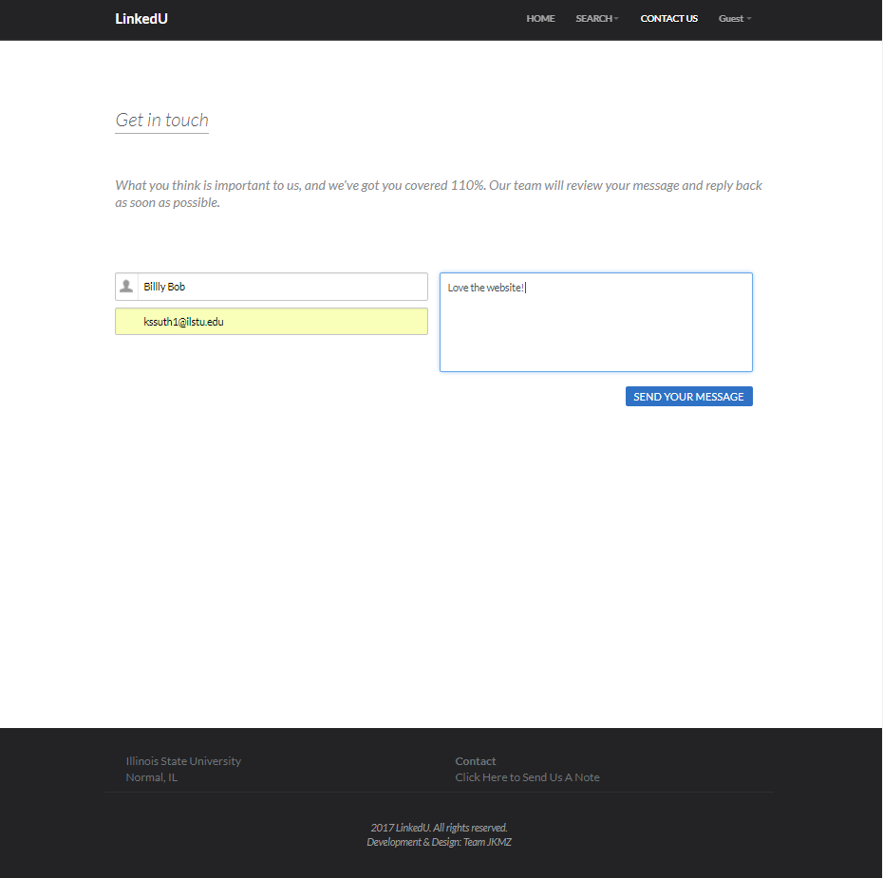

# Use Case 22: Compare Listings

Status: Not Completed

Implemented In: This was not implemented because our fourth group member never did his part, and we did not have enough time to add it.

# Use Case 23: Reports

Status: Not Completed

Implemented In: This was not implemented because our fourth group member never did his part, and we did not have enough time to add it.